AMERICAN KENPO

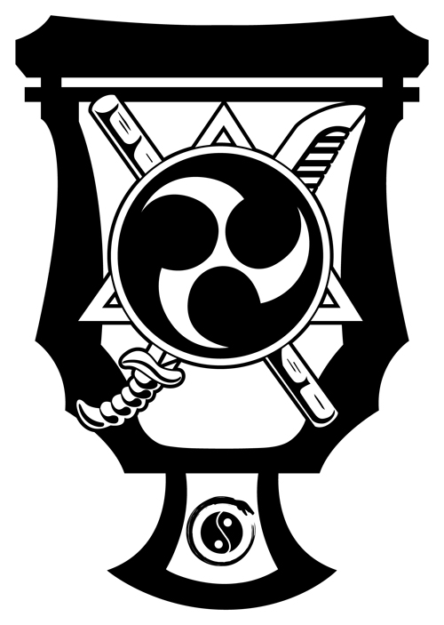

1st Degree Brown Belt Techniques

Children’s

**AMERICAN KENPO**

**1st BROWN BELT TECHNIQUES**

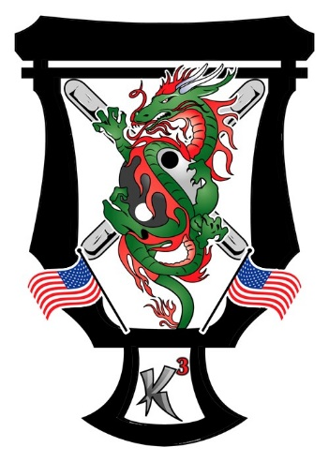

**Detour from Doom**

**Conquering Shield**

**Kneel of Compulsion**

**Circling Fans**

**Deceptive Panther**

**1stBrownTech_Hdr**

1. Detour from Doom (Roundhouse Kick)

* Drag left leg behind right foot (up the circle) as you simultaneously shoot a left downward block to the left and a right vertical punch to face
* Right kick to groin and plant
* Shift into a RFB, check low with right as you shoot a left vertical punch to midsection
* Go up the circle with left foot to 4:00 as you shoot a right back knuckle to left ribs
* Turn upper body to the right slightly and execute a left reverse claw to the left – shift back to the left with upper body and shoot a right inward hammerfist to left side of neck or nose

2. Conquering Shield (Left hand lapel Grab)

* At SAME TIME:
  + Pin with Left
  + Shoot a right inward block and slide up elbow
  + Right front ball kick to right knee buckling
* Plant right foot forward as right hand continues up
* Crash down with right elbow on top of opponents arm
* Immediately shoot a right upward elbow to chin
* Come down with right claw to face

3. Kneel of Compulsion (Flank Right Step Thru Punch)

* Step forward and to the right with the right foot to 2:00 into a RNB
* Double parry (left inward – right outward)
* Immediately step to 2:00 with left foot as right hand grabs opponents right shoulder
* Pivot further and grab opponents left shoulder with left – You are now behind
* Step back with right foot and pull down with both hands
* Shoot a right side kick to opponents left knee and plant foot as you instantly sandwich opponents head with right elbow and left heel palm
* Push down on shoulders with both arms causing him to kneel

4. Circling Fans (Front Left then Right Punch)

* Drop back with left leg into a right cat stance as you right inward parry catching left punch
* As right punch comes in left inward parry outside and right kick to groin – plant into a RNB
* Check midsection with left & come up with a right uppercut to chin
* Drop right hand down & check as you left front crossover and shoot a left vertical punch to solar plexus
* Shoot a right knee to Opponents Leg – Plant foot and deliver a right uplifting forearm strike to chin – Drop right hand sword or elbow down – pushing opponent back
* Left rear crossover and shoot a right back kick to midsection

5. Deceptive Panther (Right Front Low Kick & Right High Roundhouse Kick)

* Move your left foot up the circle to 4:00 into a right cat stance as you simultaneously deliver a left downward block to right low kick with a right inward block for high kick (Universal Block)
* Shoot a right knife edge kick to opponent’s left inner knee (Lead leg) and plant foot forward to 12:00 & deliver a right downward back knuckle to opponent’s right side mastoid & pivot clockwise into a RFB as you execute a left downward hammer fist to left kidney
* Check down with left onto shoulder as you unwind & deliver a right middle strike up to opponent’s face continuing through as you turn to 1:00 into a reverse bow
* Drag up with left to right & shoot a right heel kick to groin (or back kick for more distance