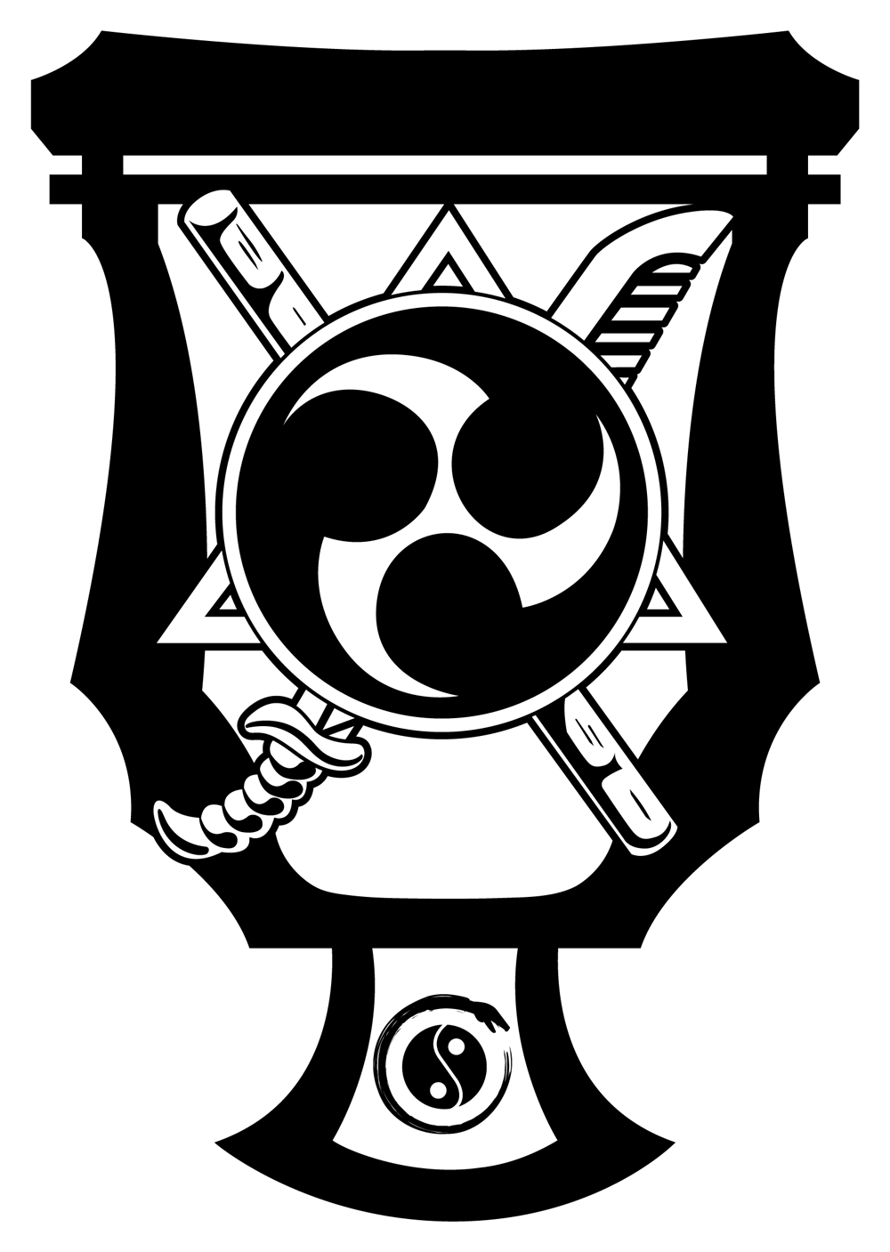

BLOCKING SET 1
The concepts focused on in this set are those of "Point of Origin." In other words, you do not have to re- chamber to execute another block. You can instantly and quickly turn one block into another. Try to imagine a star as you do this.
**REMEMBER TO KIAI ALL BLOCKS**
Start from a meditating horse stance facing 12:00.
1. Execute a right upward block.
2. Turn this into a right inward block.
3. From the inside, rotate at the shoulder and execute a right extended outward block - Palm facing out.
4. From there, circle it down counter-clockwise(across your body) and execute a right downward block.
5. Chamber the arm executing a right back elbow.
6. Execute a right push-down block.
Repeat on the opposite side, using the same sequence of blocks with the left arm.
1. Execute a left upward block.
2. Turn this into a left inward block.
3. From the inside, rotate at the shoulder and execute a left extended outward block - Palm facing out.
4. From there, circle it down counter-clockwise(across your body) and execute a left downward block.
5. Chamber the arm executing a left back elbow.
6. Execute a left push-down block.
Repeat with both sides, using the same sequence of blocks with both arms.
1. Execute two upward blocks.
2. Turn this into two inward blocks - pulling down to your chest palms facing in.
3. From the inside, rotate at the shoulders and execute two extended outward blocks - Palm facing out.
4. From there, circle both down counter-clockwise(across your body) and execute two downward blocks.
5. Chamber both arms- executing two back elbows.
6. Execute two push-down blocks.
Return to Training Horse Stance

